# Part (i)

%% Given

Rm = 2.6; %motor armature resistance 2.6 ?

Lm = 0.18; %motor armature inductance 0.18 mH

Kt = 0.00767; %motor torque constant 0.00767 N.m/A

nu_m = 1.00; %motor e?ciency 100% %

Km = 0.00767; %back-electromotive-force(EMF) 0.00767 V.s/rad

Jm = 3.9E-7; %rotor moment of inertia 3.9 × 10?7 kg.m2

Kg = 3.71; %planetary gearbox ratio 3.71

nu_g = 1.00; %planetary gearbox e?ciency 100% %

Mc = 0.57; %cart mass 0.57 kg

Mw = 0.37; %cart weight mass 0.37 kg

Lt = 0.990; %track length 0.990 m

Tc = 0.814; %cart travel 0.814 m

Pr = 1.664E-3; %rack pitch 1.664 × 10?3 m/tooth

rmp = 6.35E-3; %motor pinion radius 6.35 × 10?3 m

Nmp = 24; %motor pinion number of teeth 24

rpp = 0.01482975; %position pinion radius 0.01482975 m

Npp = 56; %position pinion number of teeth 56

KEP = 2.275E-5; %cart encoder resolution 2.275 × 10?5 m/count

%% Part (i)

%find gamma, m, Bemf

M = Mc + Mw; %kg total cart system mass

Mj = (nu_g*Kg^2*Jm)/(rmp^2); %effective mass added to the system due to the moment of inertia of the motor

m = M + Mj %

Bemf = (nu_g*Kg^2*nu_m*Kt*Km)/(Rm*rmp^2)

gamma = (nu_g*Kg*nu_m*Kt)/(Rm*rmp)

MATLAB OUTPUT:

m = 1.0731 (kg)

Bemf = 7.7236

gamma = 1.7235

# Part (ii)

%% Part (ii)

%determine largest ki for stable root locus given parameters

k = 10; %V/m

Beq = 5.4; %kg/s

c = Beq + Bemf;

num = [gamma];

denom = [m, c, gamma*k, 0];

rlocus(num,denom)

ki_max = 86.5;

poly_rooms = roots([m c gamma*k gamma*ki_max])

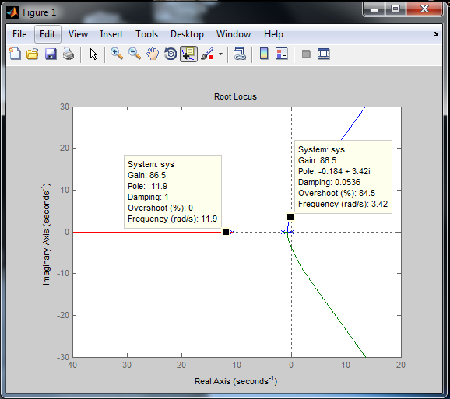

At ki_max = 86.5,

poly_rooms =

-11.8626 + 0.0000i

-0.1833 + 3.4173i

-0.1833 - 3.4173i

# Part (iii)

%% Part (iii)

kp = 1000;

ki = 20;

kd = 100;

